CS2102 Project

AY 2014-15

Team 61

Ding Xiangfei : A0113627L

Wang Yanhao : A0113742N

Implementation Details

User Interface: HTML + CSS

Web Server: Apache

Server Page Language: HTML + PHP + JavaScript

Database: MySQL

Sample SQL code & Screen Shot

1. Search Based On Hotel Name or On Hotel Address

**select** h.name, h.mailingAddress, h.zipCode,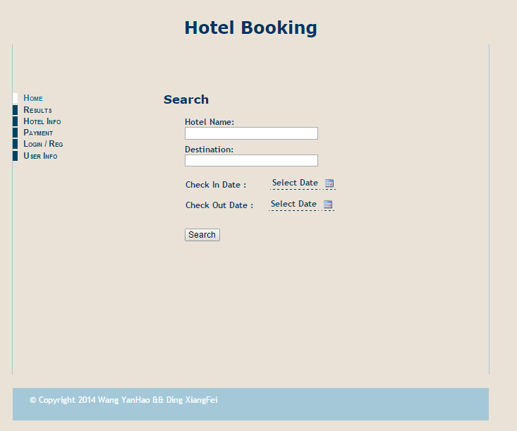

h.rating, h.contactNumber, h.image,

**count**(distinct r.roomNumber) **as** avail,

**min**(r.price) **as** minPrice, **max**(r.price) **as** maxPrice

**from** Hotel h, Room r

**where** (r.zipCode = h.zipCode) **and**

((h.name **like** ?) or (h.mailingAddress **like** ?))

**and not exists** (

**select** * **from** MakeBooking b, Contains c

**where** (b.id = c.bookingId) **and** (c.zipCode = h.zipCode)

**and** (c.roomNumber = r.roomNumber)

**and** ((b.checkOutDate > ?) **or** (b.checkInDate < ?)))

**group** by h.zipCode

1. Sort Searched Results Based on Rating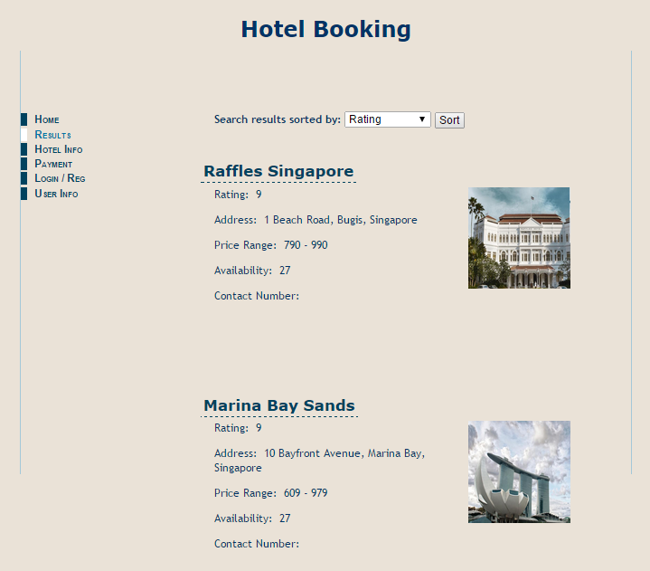

**select** h.name, h.mailingAddress, h.zipCode,

h.rating, h.contactNumber, h.image,

**count**(distinct r.roomNumber) **as** avail,

**min**(r.price) **as** minPrice, **max**(r.price) **as** maxPrice

**from** Hotel h, Room r

**where** (r.zipCode = h.zipCode) **and**

((h.name **like** ?) or (h.mailingAddress **like** ?))

**and not exists** (

**select** * **from** MakeBooking b, Contains c

**where** (b.id = c.bookingId) **and** (c.zipCode = h.zipCode)

**and** (c.roomNumber = r.roomNumber)

**and** ((b.checkOutDate > ?) **or** (b.checkInDate < ?)))

**group** by h.zipCode **order** **by** h.rating **asc**

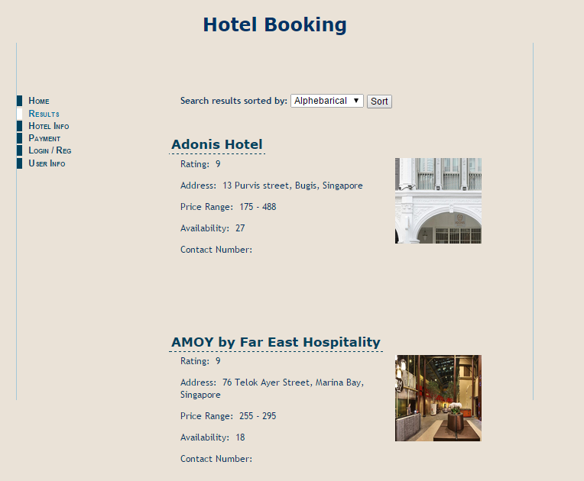

1. Booking

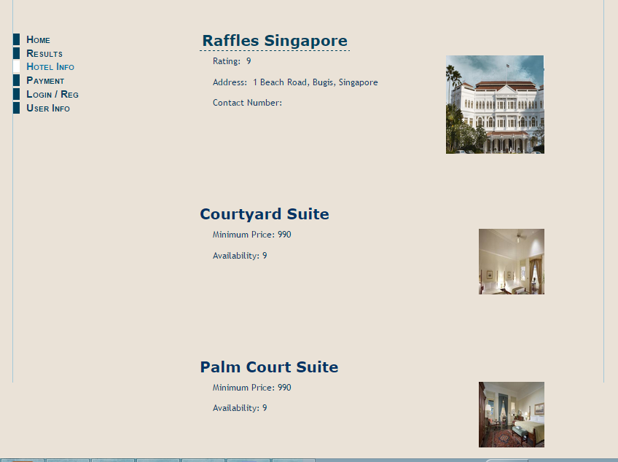

Retrieve hotel and room information

**select** h.name, h.mailingAddress, h.rating, h.contactNumber, h.image **from** Hotel h

**where** h.zipCode = ?;

**select** r.type, **min**(r.price) **as** minPrice, **count**(r.roomNumber) **as** avail, **min**(r.image) **as** image

**from** Room r

**where** (r.zipCode = ?)

**and** **not** **exists** (

**select** b.id

**from** MakeBooking b, Contains c

**where** (b.id = c.bookingId)

**and** (c.roomNumber = r.roomNumber)

**and** (c.zipCode = r.zipCode)

**and** ((b.checkOutDate > ?) or (b.checkOutDate < ?))

)

**group** **by** r.type

**order** **by** minPrice **desc**;

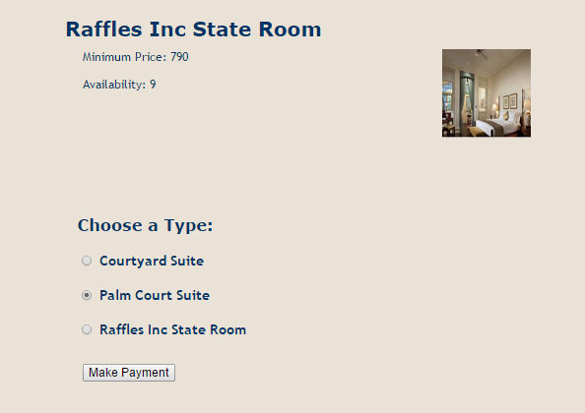

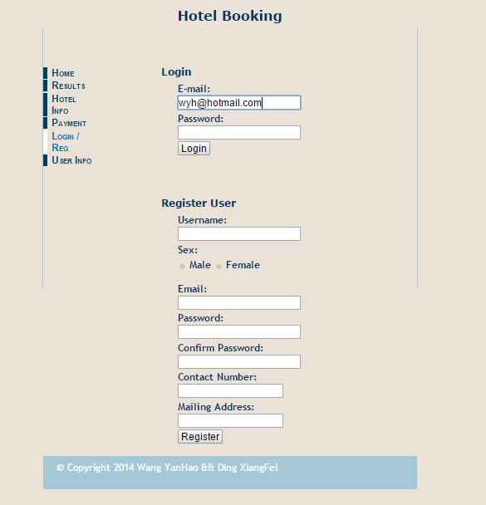

1. Booking registration

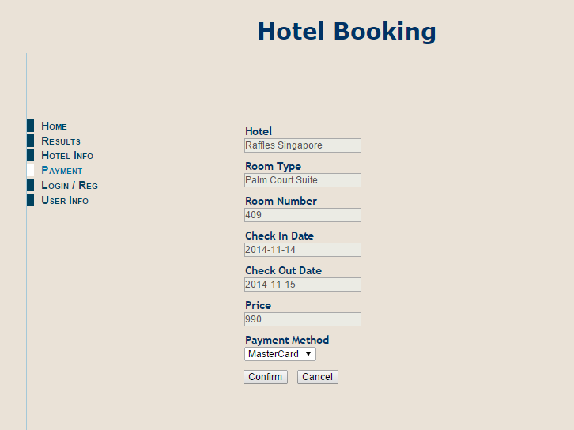

**insert** **into** MakeBooking (

id,emailAddress,checkInDate,checkOutDate,checkInTime,

checkOutTime,price,paymentMethod,payDate) **values** (?,?,?,?,?,?,?,?,null);

**insert** **into** Contains **values** (?,?,?)

1. Login and Register Page

**select** u.name, u.birthday, u.sex, u.contactNumber

**from** Customer u

**where** (u.email = ?) **and** (u.pass = ?)